Technical Design Document (TDD)

CRC cards

Architecture

Technology

Sprint 1 Report

Videos

# 

# 

# CRC cards

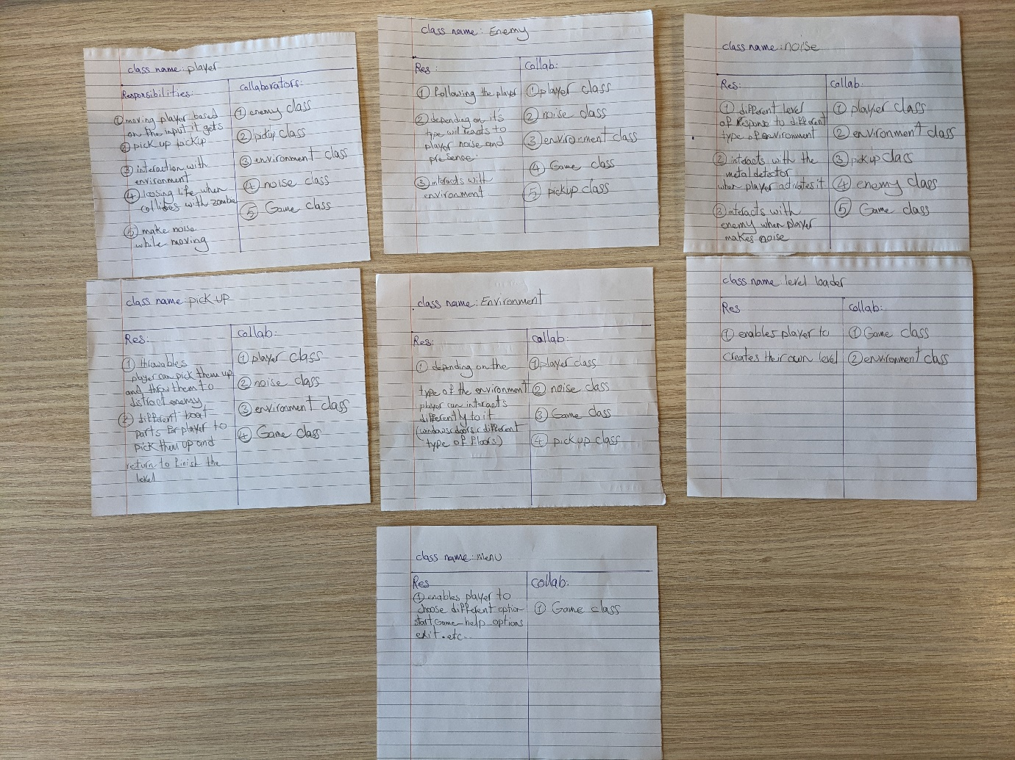

# Architecture

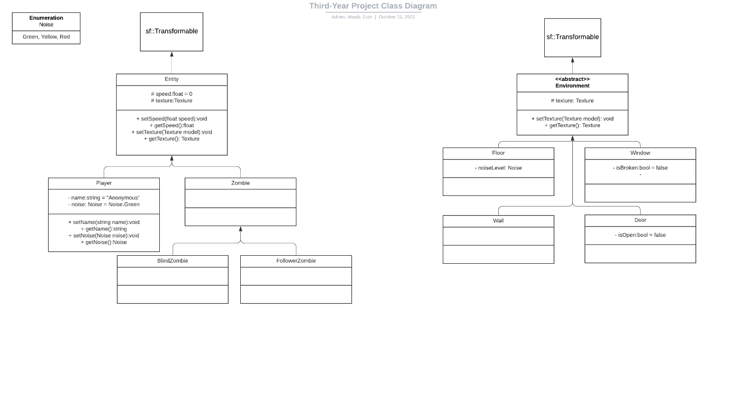

# Technology

This section should document all aspects related to the technology used in your project and will contain subheadings provided below. You will add to this section of the TDD as you encounter new technology throughout the life of the project. Include technologies not used but seriously considered.

**Research**

Begin by outlining the rationale for your technology choices (i.e. justify your choices) and any research you did in relation to support libraries or other aspects related to development. For example, if you picked one SFML GUI library over another, justify that decision. We suggest you are economical in your use of time in relation to the research element (e.g. 30 minutes max on any one particular aspect).

**Installation**

Explain how any dependencies/libraries are installed in your project. Provide URLs where the software can be downloaded.

**Technical achievement**

This section should be completed at the end of the project by each team member. You should highlight one part of the project that you felt was particularly challenging but managed to complete. This could be a pathfinding algorithm, a rendering technique, a complex game mechanic etc. Include relevant code snippets in your discussion.

# Sprint 1 Report

**Summary of planned work**

|  |  |  |  |  |
| --- | --- | --- | --- | --- |
| **Features and tasks** | **Time  Estimate** | **Time Actual** | **Team Member** | **Complete** |
| **Feature 1: Moving Player** |  |  |  |  |
| Task 1: Render a rectangle | 1 hr | 2hr | Masih |  |
| Task 2: Setup input handler | 30 min | 30 min | Masih |  |
| Task 3: Player movement | 1hr | 2hr | Adrien |  |
| **Feature 2: Enemy** |  |  |  |  |
| Task 1: Render the Enemy | 1 hr | 1hr | Masih |  |
| Task 2: Setup Collision with Player | 1 hr | 1 hr | Eoin |  |
| Task 3: creating enemy vision cone | 2 hr | 4hr | Masih |  |
| Task 4: detecting collision between player and enemy vision cone | 2 hr | 3hr | Masih |  |
| **Feature 3: Environment** |  |  |  |  |
| Task 1: Render the object | 10 min | 10 min | Eoin |  |
| Task 2: Setup Collision with player and enemies | 1 hr | 1 hr | Eoin |  |
| Task 4: Setup children to inherit from the above |  |  |  |  |
| **Feature 4: Noise** |  |  |  |  |
| Task 1: Draw the Noise | 1 hr | 1 hr | Masih |  |
| Task 2: Allow Noise to be added |  |  |  |  |
| Task 3: Make the Noise vary based on noise level | 1 hr | 2 hr | Eoin |  |
| Task 4: Setup a radius that detects nearby zombies based on noise level |  |  |  |  |
| **Feature 5: Pickups** |  |  |  |  |
| Task 1: Draw Pickups on the screen | 10 min | 10 min | Eoin |  |
| Task 2: Setup Collision with Player | 1 hr | 1 hr | Eoin |  |
| Task 3: Allow certain Pickups to be thrown |  |  |  |  |
| Task 4: Setup Collision between objects and environment |  |  |  |  |
| **Feature 6: Menu** |  |  |  |  |
| Task 1: setting up the menu buttons | 20 min | 20 min | Masih |  |
| Task 2: creating and setting up the menu | 1 hr | 1hr | Masih |  |
| Task 3: adding visual improvements | 30 min | 30 min | Masih |  |
|  |  |  |  |  |
| **Feature 7: Enemy Vision Cone** |  |  |  |  |
| Task 1: setting up the cone | 1 hr | 2 hr | Masih |  |
| Task 2: cone state changing | 30 min | 1 hr | Masih |  |
| Task 3: cone and player collision | 1 hr | 3 hr | Masih |  |
| **Feature 8: view/camera** |  |  |  |  |
| Task 1: setting up the view | 2hr | 3hr | Adrien |  |
| Task 2: render element to the view | 30min | 1hr | Adrien |  |
| Task 3: implement sf::Drawable to all the game objects | 30 min | 30 min | Adrien |  |
| **Feature 9: animation** |  |  |  |  |
| Task 1: create the Animation class | 1hr | 3hr | Adrien |  |
| Task 2: scale all the sprites | 3h | 3hr | Adrien |  |
| Task 3: create sprite sheets | 30min | 1hr | Adrien |  |
| Task 4: create the animations | 1hr | 1hr | Adrien |  |

## Videos